
HOLY CROSS COLLEGE
YEAR 10 VEHICLES AND DRIVERS
NEWTON’S LAWS OF MOTION COMPREHENSION ASSESSMENT

Name:

Teacher:

INSTRUCTIONS
- It is recommended that you take a few minutes to read the paper through carefully.
- Answer all questions in the appropriate spaces provided.
- Use BLACK or BLUE pen only.

Test Score:

21

Percentage:

NEWTON’S LAWS OF MOTION COMPREHENSION ASSESSMENT

ARTICLE 1 – WHY DO THINGS MOVE?
http://www.guardian.co.uk/science/2008/may/01/peopleinscience.physics

Why do things move?
Despite being centuries old and established without experimental evidence, Newton's laws of motion and gravity are still fit for use today, says Robert Matthews.
- The Guardian, Thursday 1 May 2008

According to legend, in 1590 Galileo Galilei climbed the Leaning Tower of Pisa and dropped two weights from the top – with consequences that overturned centuries-old beliefs about what makes things move.
The Leaning Tower legend is probably false, but there's no doubt about its metaphorical significance. At the time, centuries of dogma based on the teachings of Aristotle – and plain common sense – insisted that the heavier of the two weights would hit the ground first. Yet as Galileo showed in a series of clever, if less spectacular, demonstrations, common sense and ancient Greek philosophers are not always trustworthy. In the case of the falling weights, the heavier one does not hit the ground faster than the light one: all other things being equal, they strike the ground together.
Despite incensing rival academics, Galileo's challenge to the prevailing wisdom – his revelation that what he called the great book of nature was "a book written in mathematical language" – could not be silenced.
In 1687, a Cambridge University scholar published a book that remains the apotheosis of Galileo's assertion. Called Philosophiæ Naturalis Principia Mathematica (Mathematical Principles of Natural Philosophy), its author was Isaac Newton, whose genius would capture the laws of nature in mathematical form.
Newton's most celebrated achievement is his statement of the laws of motion. They are all the more remarkable for being based not on experimental results but on Newton's insight into the smallest number of axioms needed to derive the whole physics of motion, and explain every experimental result.
His laws pin down the concept of force with a precision that eluded Aristotle. Instead of some vague talk of an influence that causes movement, Newton stated that forces lead to changes in a property of matter he called momentum - the mass of an object, multiplied by its velocity. The greater the force, the faster the rate of change of momentum. That rate of change can manifest itself as a change in velocity; in other words, as acceleration, a concept Aristotle dodged completely as he lacked the mathematics needed to deal with it. In Newton's hands, it led directly to one of the most famous equations in all science, F=ma, which relates the force (F) acting on a mass (m) to the acceleration (a), it produces.
Law of gravitation
When combined with Newton's equally renowned law of gravitation, this formula explains the surprising outcome of the Leaning Tower experiment. It shows that the greater the value of M, the greater the force required to produce a given acceleration. Or, put more simply, large masses are just more reluctant to respond to forces. If that force is gravity, however, Newton showed that the greater the mass, the stronger the gravitational force it feels. So every falling object accelerates at the same rate under gravity, as its reluctance to respond to gravity is always compensated by the strength of gravity it feels - making its mass irrelevant.
It is testament to Newton's genius that even after 300 years, his laws of motion and gravity remain perfectly adequate for everyday use. They are still used to build bridges, design sports cars and send probes to other planets. But they have their limits.
During the early 19th century, astronomers discovered tiny anomalies in the motion of the planets which Newton's law of gravity struggled to explain. Then came challenges to even more basic ideas about motion. Experiments by American physicists in the late 19th century revealed discrepancies from the common sense rules governing relative motion. If one car overtakes another, simple mathematics shows that its relative speed is simply the difference in speeds. Yet experiments revealed that beams of light violate this rule, appearing to travel at precisely the same speed - 186,000 miles per second - regardless of the speed of those making the measurement.
This bizarre finding is at the heart of Albert Einstein's theory of special relativity, which starts from the seemingly innocuous premise that the laws of physics should be the same, regardless of how fast observers move. According to Einstein, the strange behaviour of light beams reflects the fact that their speed is a consequence of a universal law - and must therefore be the same for all observers, regardless of their speed.
Einstein then showed that this has profound consequences for Newton's laws of motion. Conceptually, it demands a fundamental reassessment of the basic ideas of space and time. Where Newton took these to be absolute and invariable, Einstein revealed them to be mutable; as seen from a stationary observer, time aboard a moving object appears to pass more slowly, and lengths shrink.
Such so-called relativistic effects only reveal themselves at speeds approaching that of light, however. At everyday speeds, Newton's laws work perfectly well. There is, however, one consequence of Einstein's theory that has a direct impact on our everyday lives. When applied to the famous law of energy conservation, special relativity leads to an equation even more famous than Newton's F=ma. It shows that matter can be a potent source of energy: E=mc2, where c is the speed of light.
It is this equation that underpins the power source of the sun and stars, and explains the destructive power of nuclear weapons.

ARTICLE 2 – NEWTON’S LAWS OF MOTION
http://www.physics4kids.com/files/motion_laws.html

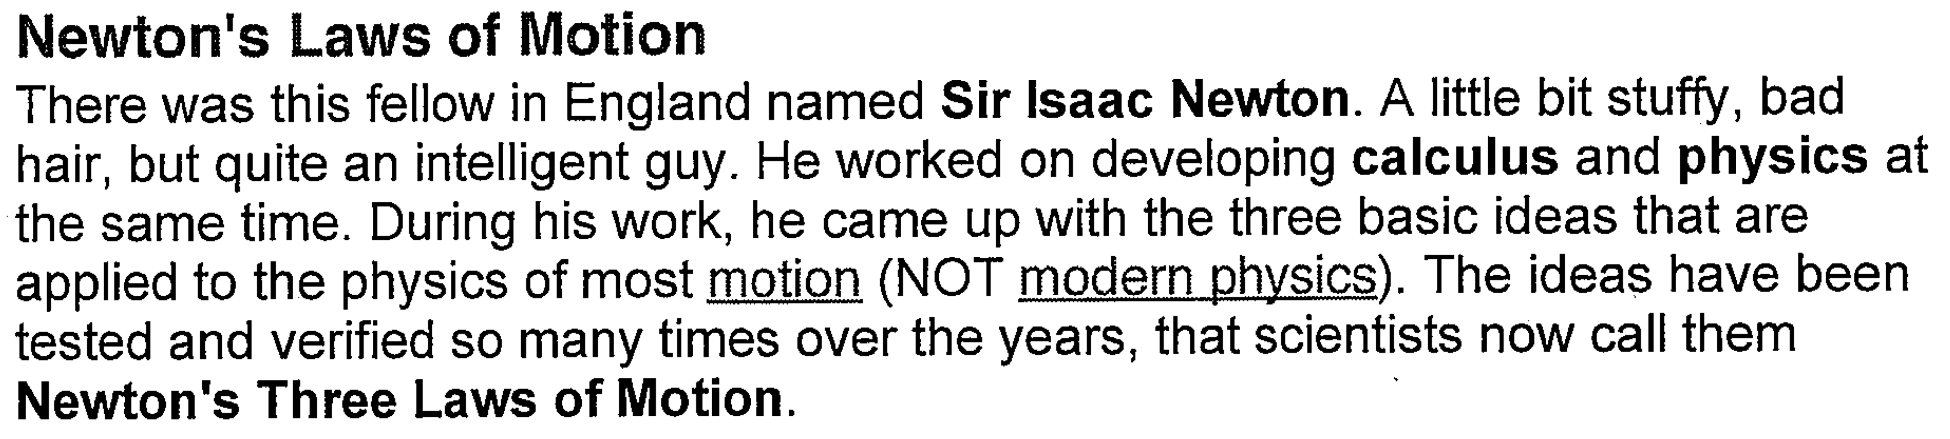

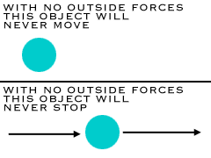
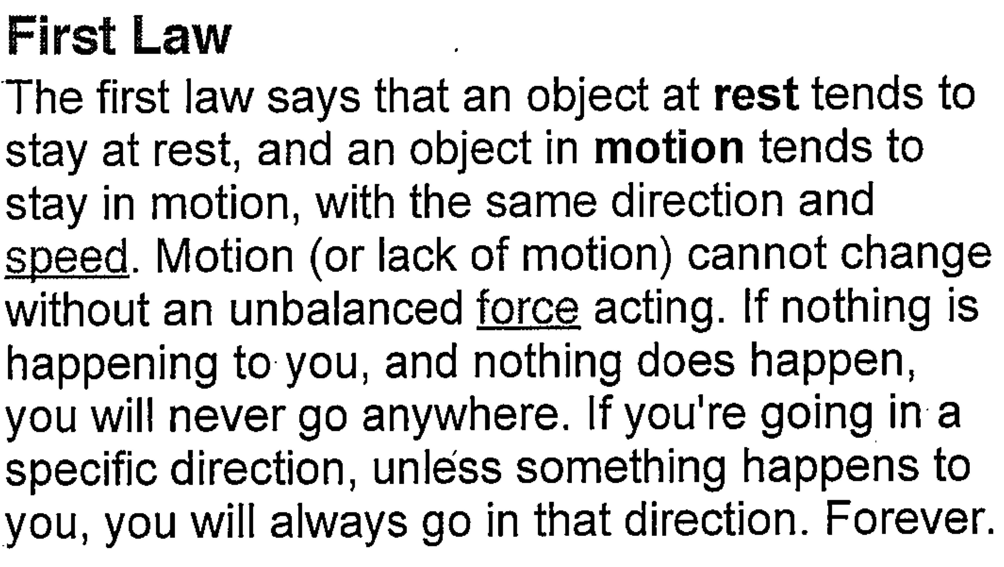

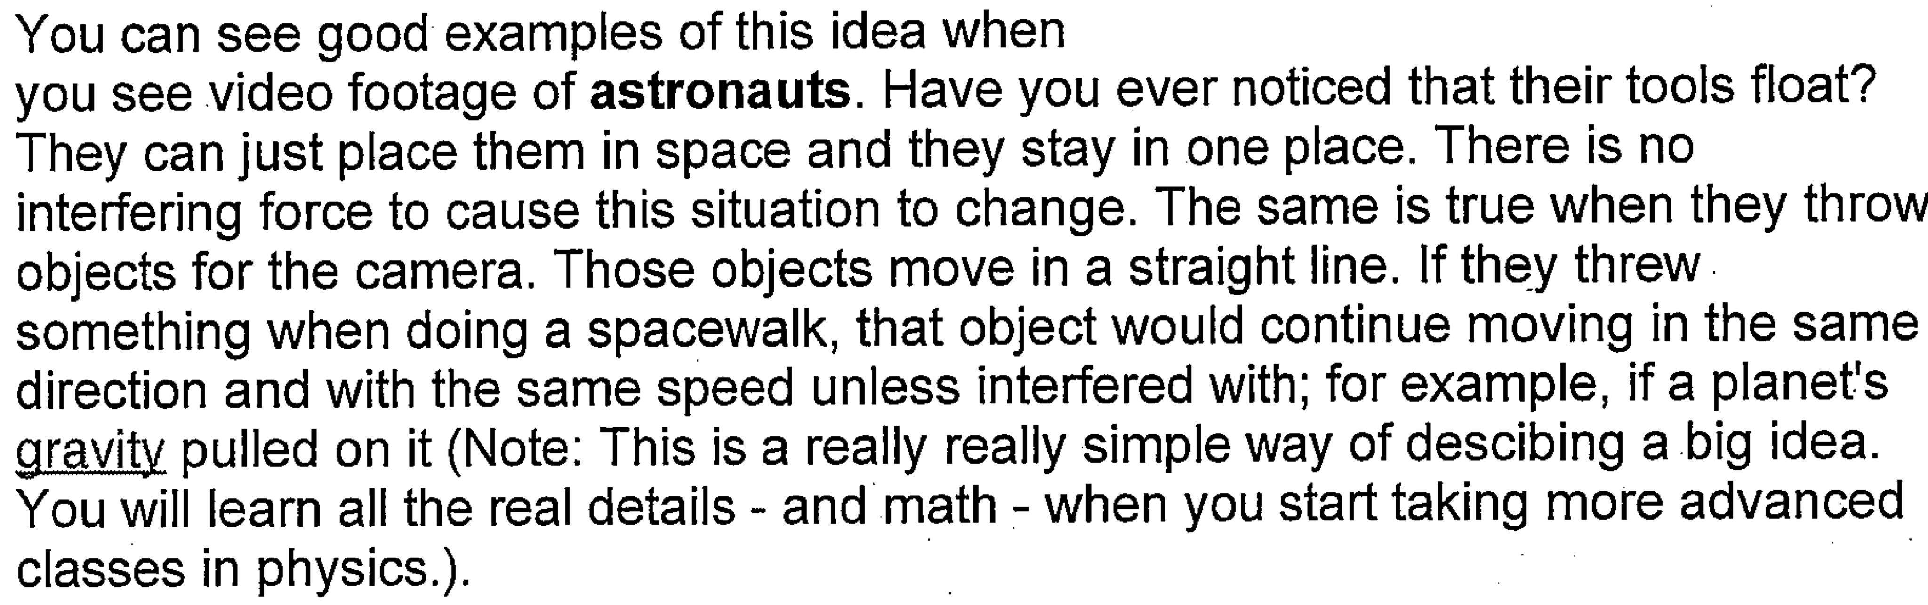

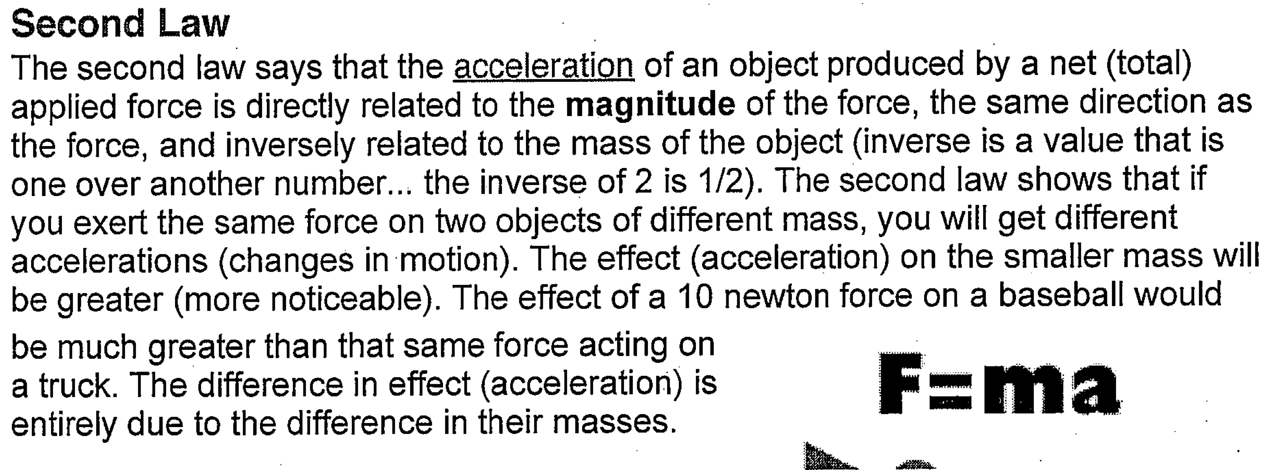
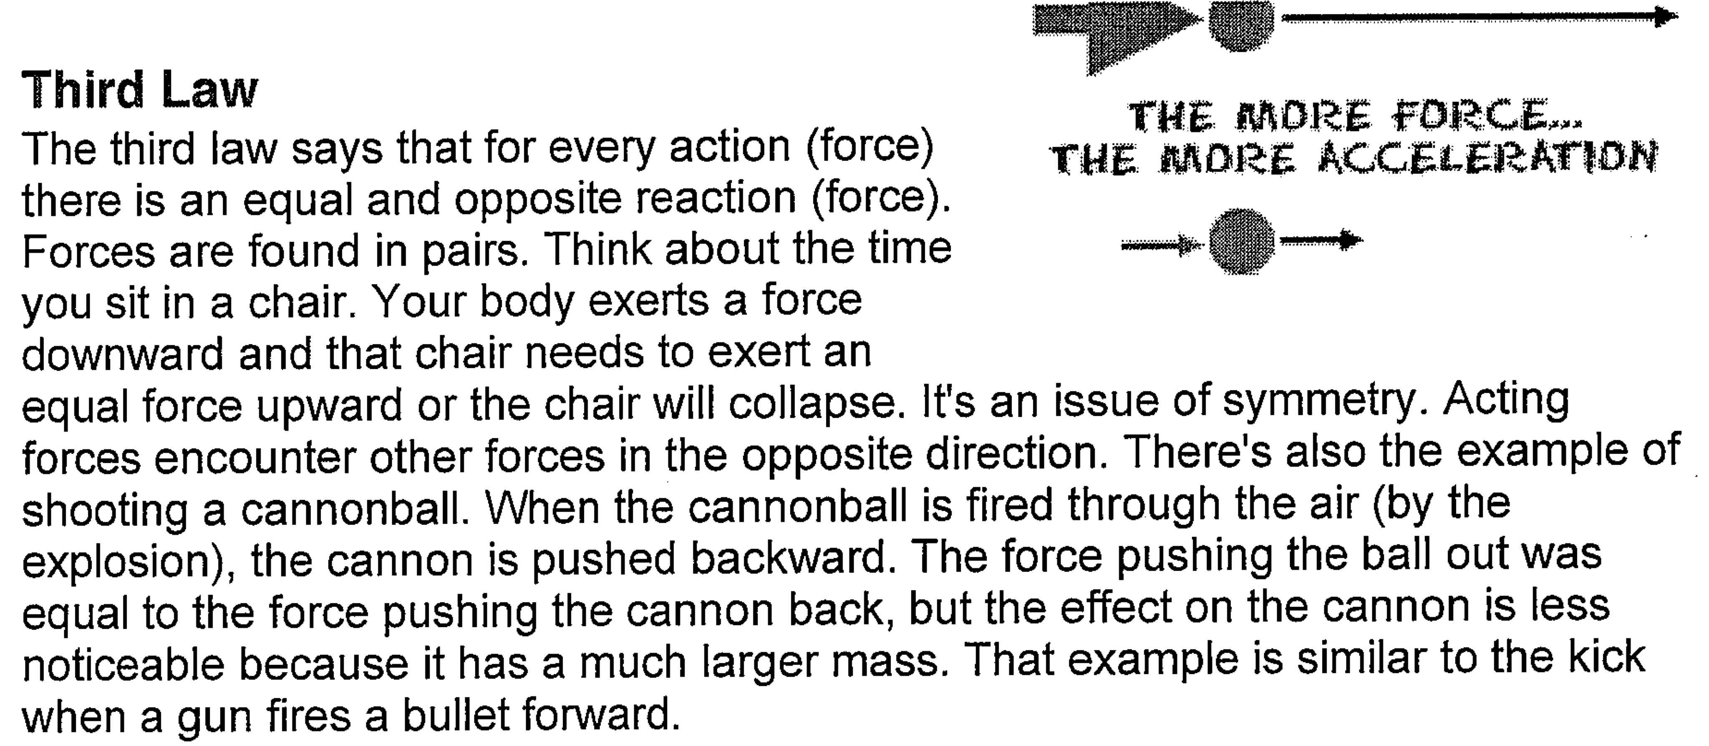

NEWTON’S LAWS OF MOTION COMPREHENSION ASSESSMENT

QUESTIONS

1. Legend has it that in 1590 Galileo Galilei dropped two weights of different mass from the top of the Leaning Tower of Pisa. What did his demonstration disprove?
__________________________________________________________________________________________________________________________________________________________
(1 mark)

2. Issac Newton is famous for many achievements in the field of maths and science, yet his most celebrated achievement is his statement of the laws of motion. What is so remarkable about them?
__________________________________________________________________________________________________________________________________________________________
(1 mark)

3. Unlike Aristotle, Newton was able to state the influence that causes movement. What was Newton’s statement?
__________________________________________________________________________________________________________________________________________________________
(1 mark)

4. Newton’s first law states that an object at rest tends to stay at ________________, and an object in ___________________ tents to stay in _________________, unless an _______________________ force acts upon it.
(2 marks)

5. Astronauts repairing a space station orbiting Earth have their tools floating around them. Explain why this happens?
_____________________________________________________________________________
(1 mark)
6. Newton formulated one of the most famous equations in science.
a) What is it?
_____________________________________________________________________________
(1 mark)

b) What does it mean?
__________________________________________________________________________________________________________________________________________________________
(2 marks)

8. Using the diagram from Question 7 identify one action/reaction pair when the car is travelling at 5 ms⁻¹.
_____________________________________________________________________________
(1 mark)

9. How does Newton’s Law of Gravitation explain the surprising outcome of the Leaning Tower experiment?
____________________________________________________________________________________________________________________________________________________________________________________________________________________________________________________________________________________________________________________
(4 marks)

10. State Newton’s third law of motion?
__________________________________________________________________________________________________________________________________________________________
(1 mark)

11. Using Newton’s third law of motion, explain what happens when a cannonball is fired from a cannon.
_______________________________________________________________________________________________________________________________________________________________________________________________________________________________________
(2 marks)

12. While Newton’s Laws of Motion are perfectly adequate for everyday use, Albert Einstein showed that they had anomalies when you apply them to the theory of special relativity. What evidence is there to show the anomalies in Newton’s Laws?
__________________________________________________________________________________________________________________________________________________________
(1 mark)

